
Youth Arts Education Program - Donation Agreement

I, ________________________ (the Donor) hereby agree to donate $_________________ to East Gippsland Art Gallery for the purpose of supporting the Youth Arts Education Program and the delivery of that program. The East Gippsland Art Gallery hereby agrees to accept the Donation and commits to using it solely for the stated purpose.
Donor Name
Postal Address
Phone
Email
Amount
Donor Signature

I wish for my donation to be made public: Yes No Date: ___________________
How you can donate:
- Credit Card over the phone 03 5153 1988
- In Person at the East Gippsland art gallery
- Direct Deposit to East Gippsland Art Gallery with your name and YAH as reference paid to Bendigo Bank BSB 633-000 Account Number 113 274 757
Thank you sincerely for your generous donation. We are thrilled to welcome you as a valued supporter of the Youth Arts Hub and Education Program. Your contribution will make a meaningful difference in the lives of young artists in our community.
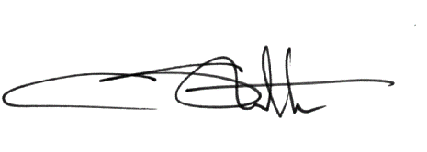
Warm regards,

Crystal Stubbs
Director
East Gippsland Art Gallery
T 03 5153 1988 | E director@eastgippslandartgallery.org.au
All donations to East Gippsland Art Gallery are Tax Deductible. East Gippsland Art Gallery is a registered charity and endorsed as Deductible Gift Recipient, Items 1 and 4 of the table in Section 30-15 of the Income Tax Assessment Act 1997. All donations over $2 are tax-deductible. A receipt can be emailed to you on request.

